Communications Guide
California Food Waste Prevention Week
March 5-9, 2018 | #SaveTheFoodCA
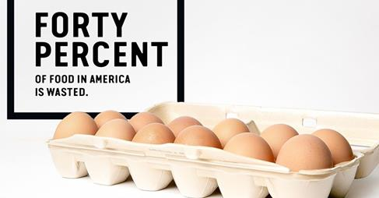
Purpose: A coordinated multi-sectoral effort to raise awareness about the impacts of food waste in California during the week of March 5th – 9th.
Target Audiences:
1) The internal workforce of partnering organizations will receive messages from leadership and be asked to participate in a Food Waste Reduction Hero Photo Challenge.
2) The broader professional networks of partnering organizations will receive this packet and encouragement to join in issuing shared messaging and participating in the Food Waste Reduction Hero Photo Challenge.
3) The general public may learn of Food Waste Prevention Week through social media messages or news coverage.
Food Waste Prevention Week was Developed and Planned by Multiple Partners
Founding Partners: Public Health Alliance of Southern California & Nutrition Policy Institute, University of California Division of Agriculture and Natural Resources
Planning Partners: Governor’s Office of Planning and Research, State of California; Berkeley Media Studies Group; CalRecycle; California Department of Education; California Department of Food & Agriculture; California Department of Public Health; California Dietetic Association; Dairy Council of California; Natural Resources Defense Council; Public Health Institute; University of California, Division of Agriculture and Natural Resources (UCANR); UC CalFresh Nutrition Education Program; and UCANR Nutrition, Family, and Consumer Sciences Program and Expanded Food and Nutrition Education Program.

About the Development of California Food Waste Prevention Week 2018
January 29, 2018
In February 2017, the Public Health Alliance of Southern California and the Nutrition Policy Institute, University of California Division of Agriculture and Natural Resources jointly convened state agencies delivering nutrition education programming to discuss the impacts of food waste and strategize solutions the agencies could advance together.
The planning group identified an opportunity to generate and issue shared messaging during National Nutrition Month, an initial collective goal which has evolved into California’s first Food Waste Prevention Week from March 5th-9th, 2018. This communications guide was developed by the founding partners, in collaboration with the planning partners listed on the cover page.
We are grateful to the Natural Resources Defense Council for their willingness to share the Save the Food campaign materials and allow all partners to co-brand them free of charge. Thank you to everyone for partnering to launch Food Waste Prevention Week in California!
While this has been a collaborative effort, Stephanie Caldwell at the Public Health Alliance with the support of Joyce Lee at NPI did much of the heavy lifting to produce the materials included in this guide. If you have any questions or comments, please send them to SaveTheFoodCA@gmail.com.
We are excited to launch California’s Food Waste Prevention Week! Thank you for your partnership and collaboration.
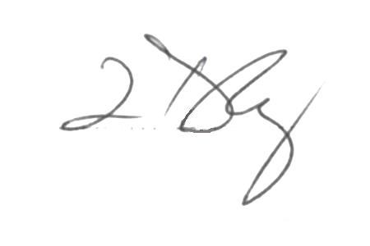
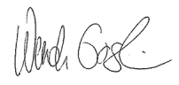
Cheers,

Tracy Delaney, PhD Wendi Gosliner, DrPH, RD
Executive Director Project Scientist
Public Health Alliance of Southern California Nutrition Policy Institute, University of California Division of Agriculture and Natural Resources

Communications Guide Contents
About the Development of California Food Waste Prevention Week 2018 2
Overview of Food Waste Prevention Week 3
Monday, March 5, 2018 – Official Organizational Launch 4
DRAFT Organizational Message 5
DRAFT Script for Organizational Video Message 8
DRAFT Leadership Endorsement 10
DRAFT Local Partners Press Release 12
Save the Food CA Web Banners 14
Save The Food CA Graphic Display Options 15
DRAFT Messaging for Monday March 5, 2018 23
DRAFT Local Jurisdiction Proclamation 25
Tuesday, March 6, 2018 – Find Food Waste 25
DRAFT Messaging for Tuesday, March 6, 2018 26
Wednesday, March 7, 2018 – Prevention by People 27
DRAFT Messaging for Wednesday March 7, 2018 28
Thursday, March 8, 2018 – Prevention in Communities & Worksites 29
DRAFT Messaging for Thursday March 8, 2018 29
Friday, March 9, 2018 – Keep it Going! 31
DRAFT Messaging for Friday, March 9, 2018 31
Advance Prep Overview and Suggested Timeline 33
Appendix: 34
Anticipated State Agency Announcements for Food Waste Prevention Week 34
DRAFT Collective Press Release 35
Why a Food Waste Reduction Hero Photo Challenge? 37

Overview of Food Waste Prevention Week
The week of March 5-9, 2018 is California’s inaugural Food Waste Prevention Week. Food waste is a significant issue in California.
- The United States is losing up to 40% of its food from farm, to fork, to landfill. Uneaten food wastes enormous quantities of precious land, water, energy, fertilizer, human resources and money.
- In California, nearly 5 million people are food insecure, lacking consistent access to enough food. Roughly 1 in 8 Californians are experiencing hunger, and 1 in 5 of those are children.
- Food waste also represents the largest single category of waste in landfills in the US. Food waste decaying in landfills emits methane, a powerful greenhouse gas linked to climate change.
During this week, a range of partners statewide will come together to raise awareness about the impacts of food waste in our homes, workplaces, and communities.
What Partnering Organizations Can Do:
March 5, 2018 – Official Organizational Launch
- Endorse or Declare Food Waste Prevention Week
- Issue All-Staff Communications
- Present the Food Waste Reduction Hero Photo Challenge
- Public messaging to Launch the Week

March 6, 2018 – Find Food Waste
- Encourage pictures of where food waste is happening
- Public messaging about why food waste matters

March 7, 2018 – Prevention by People
- Encourage pictures of how people will prevent food waste in their homes
- Public Messaging about individual solutions

March 8, 2018 – Prevention in Communities & Worksites
- Encourage pictures of how people will prevent food waste in their communities
- Public messaging about community-level solutions
- Public messaging about climate/natural resource impacts

March 9, 2018 – Keep it Going!
- Public messaging to spark ongoing actions to reduce food waste in CA

Monday, March 5, 2018 – Official Organizational Launch
Activities: | - Share your Leadership Endorsement;  - Issue an all-staff communication in writing (newsletter, blog or e-blast) announcing the week and the Food Waste Reduction Hero Photo Challenge;  - Share a video message with your workforce;  - Issue a local press release about your organization’s food waste prevention efforts;  - Place web banners on internal- and external-facing websites for the week;  - Display co-branded posters in public meeting areas;  - Issue social media messages related to the launch of the week.  If today is your jurisdiction’s regular public meeting day, and elected officials will be issuing a local declaration, be sure to promote that activity on social media and to your workforce.
Tasks to Complete in Advance:: | - Schedule time with your Agency Director or Department Head to establish buy-in and support for Food Waste Prevention Week activities;  - Designate and orient staff best positioned to lead or assist coordination of Food Waste Prevention Week activities;  - Finalize a Leadership Endorsement on Food Waste Prevention Week;  - Schedule time with your Director or Department Head to tape a video message for the workforce;  - Secure space on public meeting agendas, as appropriate, to have elected officials formally proclaim or declare Food Waste Prevention Week in their jurisdiction during the week of March 5th;  - Obtain final organizational approval for co-branding any print materials with your logo. Arrange to print, disseminate and display co-branded poster for lobbies/public waiting spaces. Designate a staff member to coordinate distribution of the posters.  - Finalize the video script with organizational context, shoot the video message and make any final preparations for dissemination to the workforce;  - Obtain final organizational approval for social media messages to be posted throughout the week and task a designated staff member to post the messages and associated videos/ resources on public-facing platforms, as appropriate;  - Task a designated staff member to post approved co-branded images or web banners to internal and/or external websites, as appropriate;  - If your organization will issue a press release or engage local media outlets, finalize the press release to be issued on 3/5/18. Don’t forget: identify a spokesperson to be ready to respond to any media inquiries.
Support Materials That Follow: | Draft Organizational Message; Draft Script for Video Message; Draft Leadership Endorsement; Draft Local Press Release; Web Banners from Natural Resources Defense Council (NRDC); Draft Graphics from NRDC to be co-branded for posters/flyers; Draft Social Media Messages for Day 1; Draft Local Jurisdiction Proclamation

DRAFT Organizational Message
For Newsletters, Blogs or All-Staff Email
Governor Jerry Brown has issued a letter of support and several state agencies have announced the week of March 5-9, 2018 as California’s first Food Waste Prevention Week. Happening in March to coincide with National Nutrition Month, partners nationwide are urging everyone to Go Further with Food. According to the California Department of Resources, Recycling and Recovery (CalRecycle), Californians throw away nearly 12 billion pounds of food each year, wasting precious land, water, energy, and human resources and contributing about 18 percent of all the material that goes to our landfills.
While many people may not think much of tossing food in the trash, consumers are responsible for more wasted food than farms, grocery stores, or restaurants. Forty percent of all food thrown out happens at the individual or household level. Unused food can add up financially for families. The Natural Resources Defense Council estimates that an average family of four tosses out about 1,000 pounds of food each year, wasting roughly $1,500.
There are other costs from our unused food. The United States is losing up to 40% of its food from farm, to fork, to landfill. That translates to $218 billion lost including costs of food to consumers and retailers, as well as wasted water, energy, fertilizer, cropland, production and transportation. When food decomposes in landfills, it releases methane gas - a climate pollutant 80 times more potent than carbon dioxide (CO₂).
The quality and amount of food that people eat each day play a vital role in health and wellbeing. A 2014 USDA report estimated that a staggering 1,249 calories per person, per day in the United States are wasted—more than enough to feed all the 1 in 8 Californians currently experiencing hunger and food insecurity. That nutrition loss could have fed people, not landfills, if only it had been used, instead of tossed. According to Feeding America, over 4.8 million Californians experience hunger or food insecurity, over 1.8 million of whom are children.
Reducing food waste requires action by partners throughout the food system, including food growers, processors, and retailers. But it also requires action from all individuals as well as agencies, organizations, businesses, and community groups. For example, there are many ways for various groups to reduce waste as well as to rescue food and donate it locally.
[PLACEHOLDER: Highlight here your organization’s efforts and food waste prevention projects.]
During Food Waste Prevention Week, we are issuing a Food Waste Reduction Hero Photo Challenge to our workforce and, as appropriate, to our external partners and the public. Reducing food waste in your home, workplace and community requires some thinking and planning. We ask that you join us and take the Challenge!

All you have to do is take a few photos (drawings and videos also accepted) with short captions that demonstrate:
1) How food waste happens in your home, workplace or community; and
2) Barriers you face in reducing the amount of food you throw away, such as the food packaging or portion size options available for purchase, bulk pricing incentives, storage or time constraints, food disposal options, etc.; and
3) What actions, or changes, you are making or solutions you see happening around you to reduce food waste.
Submissions can include before and after pictures, or pictures identifying the food that is the hardest to stop discarding in your household. Some solutions-based photos might include things like imperfect or ugly produce being used, appropriate portion sizes on plates, freshly frozen food to be used at a future date, excess fresh produce from a bulk retailer being shared with neighbors, or any other creative strategies you want to highlight. Simply share your submissions via social media platforms using the hashtag #SaveTheFoodCA and tag @SaveTheFood on Twitter and/or Instagram or email them to SaveTheFoodCA@gmail.com. Please include your location and organizational affiliation (employee or patron of which participating agency) with your submission.
Incorporating a few simple food waste prevention actions - such as freezing food and using leftovers – can immediately help reduce food waste.
Stay tuned all week for resources, tips, and ideas. To learn more, please visit Save The Food. Interested in other ways to reduce food waste? Check out the Public Health Alliance of Southern California’s Resource Library and CalRecycle’s Resource Directory.

DRAFT Script for Organizational Video Message
- Hello! I’m [name], [title] and I am here to talk about uneaten food.

- It’s Food Waste Prevention Week in California. The Governor has issued a letter of support for Food Waste Prevention Week from March 5-9, 2018. I’m proud that our dept/agency/organization is teaming up with the Governor’s Office of Planning & Research, CalRecycle, University of California, Division of Agriculture and Natural Resources, and its Nutrition Policy Institute, the Public Health Alliance of Southern California and many more partners – statewide - to collectively urge people to become Food Waste Reduction Heroes this week.

- Unused food is a significant issue. Californians throw away nearly 12 billion pounds of food each year. That ends up comprising about 18 % of all the material in our landfills.

- It can be surprising to learn that much of the food waste is generated in our homes. In fact, up to 40% of all wasted food is discarded at the individual or household level.

- Uneaten food can add up for families. An average family of four throws out about 1,000 pounds of food each year, paying about $1,500 for food that goes unused.

- There are other costs from our unused food. We all lose out on shared resources -- like the wasted water and energy that went into producing and transporting that food on the front end. And, on the back end, when food rots in our landfills, it releases methane - a climate pollutant 80 times more potent than carbon dioxide (CO₂)– which contributes to climate change. Fortunately, we can change this.

- There is a role for everyone in food waste reduction. To meaningfully limit the volume of food in our landfills, action is required by large agencies, organizations, businesses, institutions and community groups to reduce food waste generated within their operations.

- Food waste is something our organization cares about because [PLACEHOLDER for contextual relevance].

- During this year’s Food Waste Prevention Week, I have decided to join several agencies statewide to issue a Food Waste Reduction Hero Photo Challenge to our workforce and, where it’s appropriate, to our external partners, too.

- I’m taking on the challenge and hope you will join me! Participating will help us all become more aware of the causes of our own food waste and can generate ideas for potential solutions by sharing how difficult it can be to reduce food waste in your environment. The challenge is pretty simple. All you have to do is take a few photos (drawings and videos also accepted) that demonstrate:
1) How food waste happens in your home, workplace or community; and
2) Barriers you face in reducing food waste such as such as the food packaging or portion size options available for purchase, bulk pricing incentives, storage or time constraints, food disposal options, etc.; and
3) What actions, or changes, you are making or you see others making to reduce food waste in homes, workplaces, and communities.

- Submissions can include before and after pictures, imperfect or ugly produce being used, appropriate portion sizes served, freshly frozen food to be used at a future date, or excess fresh produce from a bulk retailer being shared with neighbors. You are encouraged to be creative.

- Simply share your submissions via social media platforms using the hashtag #SaveTheFoodCA and tag @SaveTheFood on Twitter and/or Instagram or email them to SaveTheFoodCA@gmail.com. Please include your location and include mention of our dept/agency/organization with your submission.

- Even incorporating a few simple food waste prevention actions - such as freezing food and using up any leftovers - has great potential to reduce food waste in California. And paying attention to why you waste food may also highlight other changes that could help you waste less, like being able to buy smaller portions of food in the store or order smaller portions in restaurants. Your efforts to be a Food Waste Reduction Hero this week, and into the future, will be impactful.

- So, thank you for helping to make a difference during this year’s Food Waste Prevention Week.

DRAFT Leadership Endorsement
<Agency/Leader Name> is pleased to announce March 5th through 9th, 2018, as “Food Waste Prevention Week” in the State of California in conjunction with Governor Brown, and other California officials and agencies.
Up to 40% of the food in the United States goes uneaten. CalRecycle estimates that Californians throw away almost 12 billion pounds of food each year. That food waste amounts to 18% of all landfill use in this state. In contrast, nearly 5 million Californians are food insecure, lacking consistent access to sufficient, safe and nutritious food to lead a healthy, active life.
Food waste prevention also aligns with California’s 75 Percent Initiative to significantly reduce solid waste in landfills by 2020. The food in landfills decomposes and releases methane, a greenhouse gas 80 times stronger than CO₂ at trapping heat that contributes to climate change. Money spent on energy, water, fertilizer, land, production, storage, transportation, and retail food purchases is lost when food goes unused. A family of four spends on average $1,500 annually toward 1,000 pounds of uneaten food. To reduce greenhouse gas emissions and protect shared resources, it is imperative that everyone takes part to divert usable food from landfills.
This week, in alignment with National Nutrition Month’s theme of “Going Further with Food” and <Agency/Leader Name>’s mission of [protecting community health, combatting food insecurity, mitigating climate change, preserving natural resources, etc.], we endorse Food Waste Prevention Week. < Agency/Leader Name > commits to encouraging [its partners, workforce and the public] to take simple food waste prevention actions such as sharing or freezing food before it becomes inedible and using leftovers. Our [partnering/ worksite] participants are also asked to consider and photograph food waste solutions as well as the factors in their homes, worksites, or communities that make food waste prevention difficult due to current purchasing, storage, or disposal options. The visual feedback can prompt continuing statewide innovations from this coordinated multi-sectorial effort to support all Californians in reducing waste. Taking steps to be aware of food waste and to initiate changes to prevent it has the power to reduce waste, feed people rather than landfills, combat climate change and save economically. Working together, we can Save The Food in California.

Signed: _________________________________
Date: _________________________________

Please scan and return signed endorsement to SaveTheFoodCA@gmail.com by March 5, 2018.

DRAFT Local Partners Press Release
For Immediate Release:  March 5, 2018 | For more information contact:  <Office>  <Phone>  <Email>

<AGENCY NAME> CHALLENGES WORKERS TO BE FOOD WASTE REDUCTION HEROES FOR FOOD WASTE PREVENTION WEEK
<LOCATION (CITY/ COUNTY)> – <Agency Name> collaborates with Governor Jerry Brown, and other California officials and agencies *please reference latest version of the Communication Guide at http://phasocal.org/ prior to issuing the local press release* to announce March 5-9, 2018, as “Food Waste Prevention Week” in the State of California. <Agency Name> pledges to raise employee and public awareness about the economic, environmental and social impacts of unused food.
“Almost 12 billion pounds of food gets thrown away in California each year, and that loss of food has ripple effects in our communities,” said [PLACEHOLDER: Organizational Leader, Title]. “Across the state nearly 5 million people are food insecure [replace this piece with a local statistic, if known]. We need to do better, to ensure all Californians have access to safe, affordable, and adequate healthy foods. At the same time, we need stronger waste prevention efforts as well as more robust local food donation and food recovery systems and convenient and consistent residential, retail, and office green waste disposal systems to reduce the volume of usable food sitting in landfills.”
Consumers contribute to more food waste than grocery stores and restaurants combined. Forty percent of all food waste happens at the individual or household level, and ninety percent of Americans throw away food too soon based on unfamiliarity with confusing expiration date labels. The Natural Resources Defense Council estimates that an average family of four tosses out about 1,000 pounds of food each year, wasting roughly $1,500 on food that goes unused.
Food Waste Prevention Week aims to raise awareness in California about solutions that residents can implement in their homes, workplaces and communities to limit food waste, which can be challenging based on purchasing, storage, and disposal limitations. Beyond consumer level behavior changes, Food Waste Prevention Week prompts all people to consider where waste is happening around them and what they can do about it. Solutions might include seeking out imperfect produce, asking for composting bins to be installed at the office or a community center, or working with school administrators to arrange for a share table in the lunch area. Other ways to participate include identifying what would be the hardest food to stop discarding in your household and sharing that information to stimulate ideas to address the issue.
Food waste is also the single largest component of landfills. Once it gets trucked there, food decomposes and releases methane - a climate pollutant 80 times more potent than carbon dioxide (CO₂).
“<Agency> is committed to reducing food waste because <insert organizational context>,” said [PLACEHOLDER: Leader last name]. “Recognizing the potential each of us has to personally affect how much food goes unused, I support Food Waste Prevention Week and will take actions to reduce food waste in my home, workplace and community.”
For more information on how to store, save and use food, please visit SaveTheFood.com.
<Insert Agency Mission and how it relates to Food Waste Prevention>
###

Save the Food CA Web Banners
These images have been created for use as website banners or buttons. We have approval from the Natural Resources Defense Council (NRDC) to allow Food Waste Prevention Week partners to place these graphic images on their public-facing internet webpages, as well as internal-facing intranet webpages. The images have been created in two sizes: 1000x300 pixels for full page width applications; and 825x300 pixels for smaller display options.
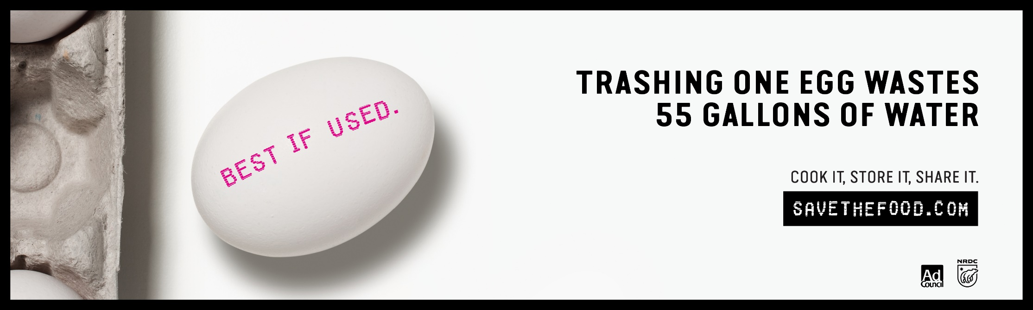
Figure 1: 1000x300 Pixel Web Banner - Egg
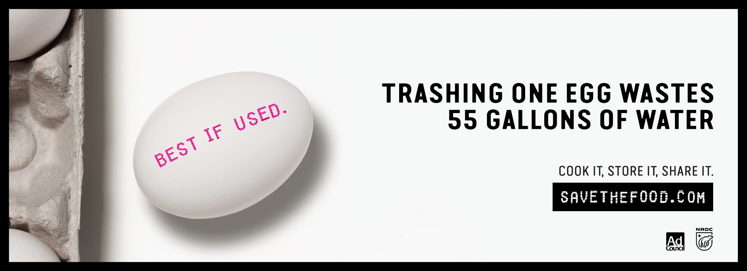
Figure 2: 825x300 Pixel Web Banner - Egg
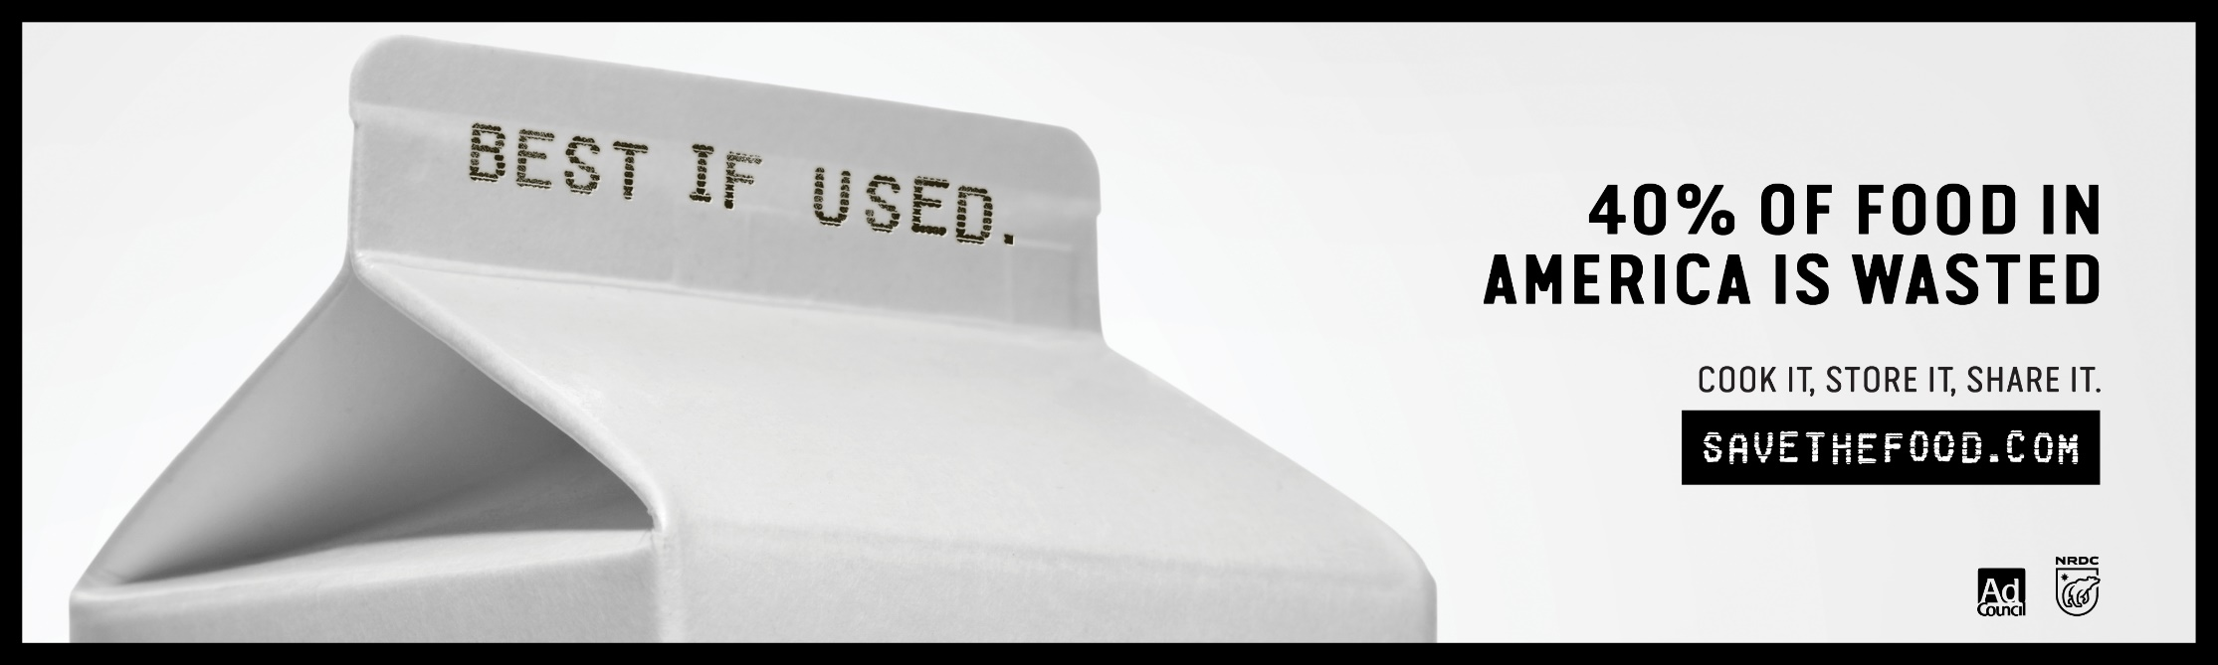
Figure 3: 1000 x 300 Pixel Web Banner - Milk

Figure 4: 825x300 Pixel Web Banner - Milk
Save The Food CA Graphic Display Options
These individually co-brandable materials are normally used a flyers or posters. We have approval from the Natural Resources Defense Council (NRDC) to allow Food Waste Prevention Week partners to customize these graphics with their individual logo in the upper left corner. These images are designed to be 8.5x11 and you are encouraged to use these as large posters for display in building lobbies or waiting areas during the week. To use, simply select the image you wish to co-brand, right click on the graphic, save the picture and insert your organizational logo in the designated areas.
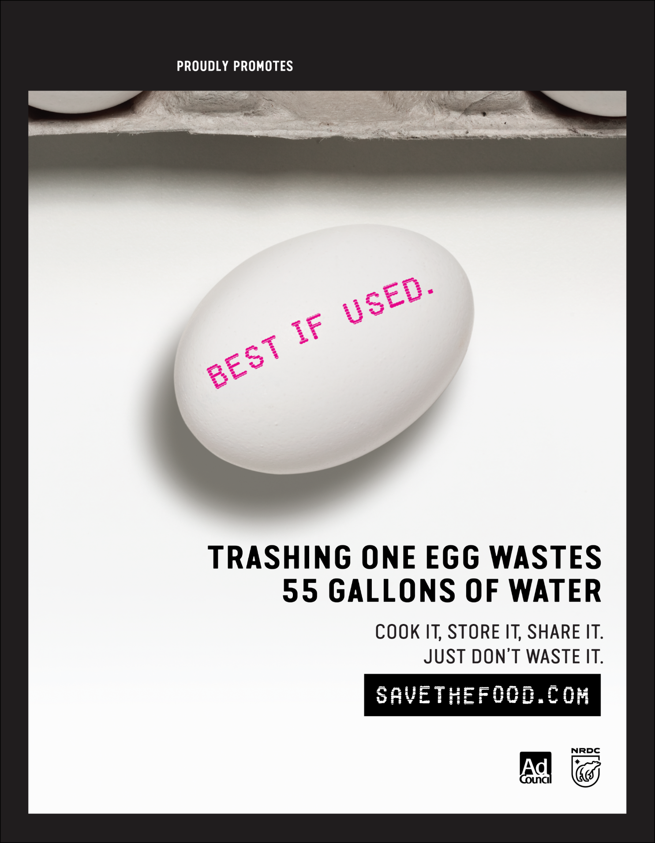
Figure 5: Approved for Co-Brand Upper Left Corner – Egg
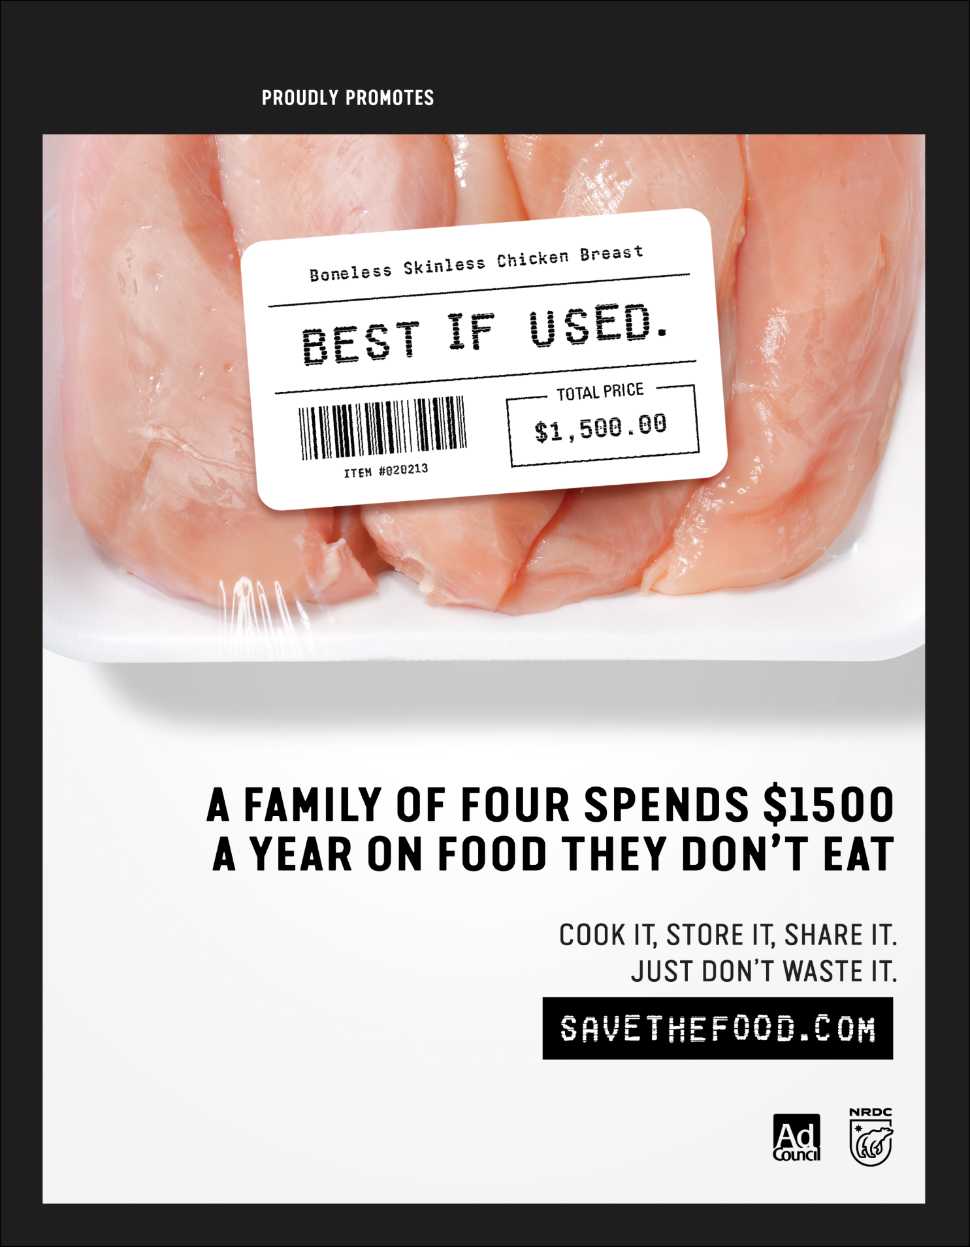
Figure 6: Approved for Co-Brand Upper Left Corner – Chicken
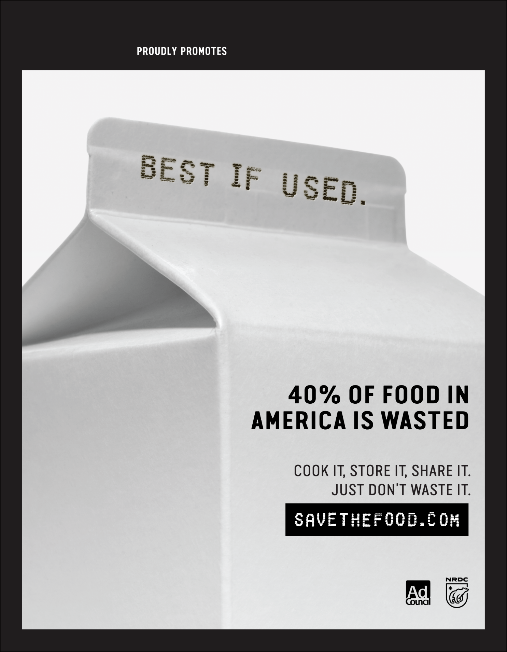
Figure 7: Approved for Co-Brand Upper Left Corner – Milk
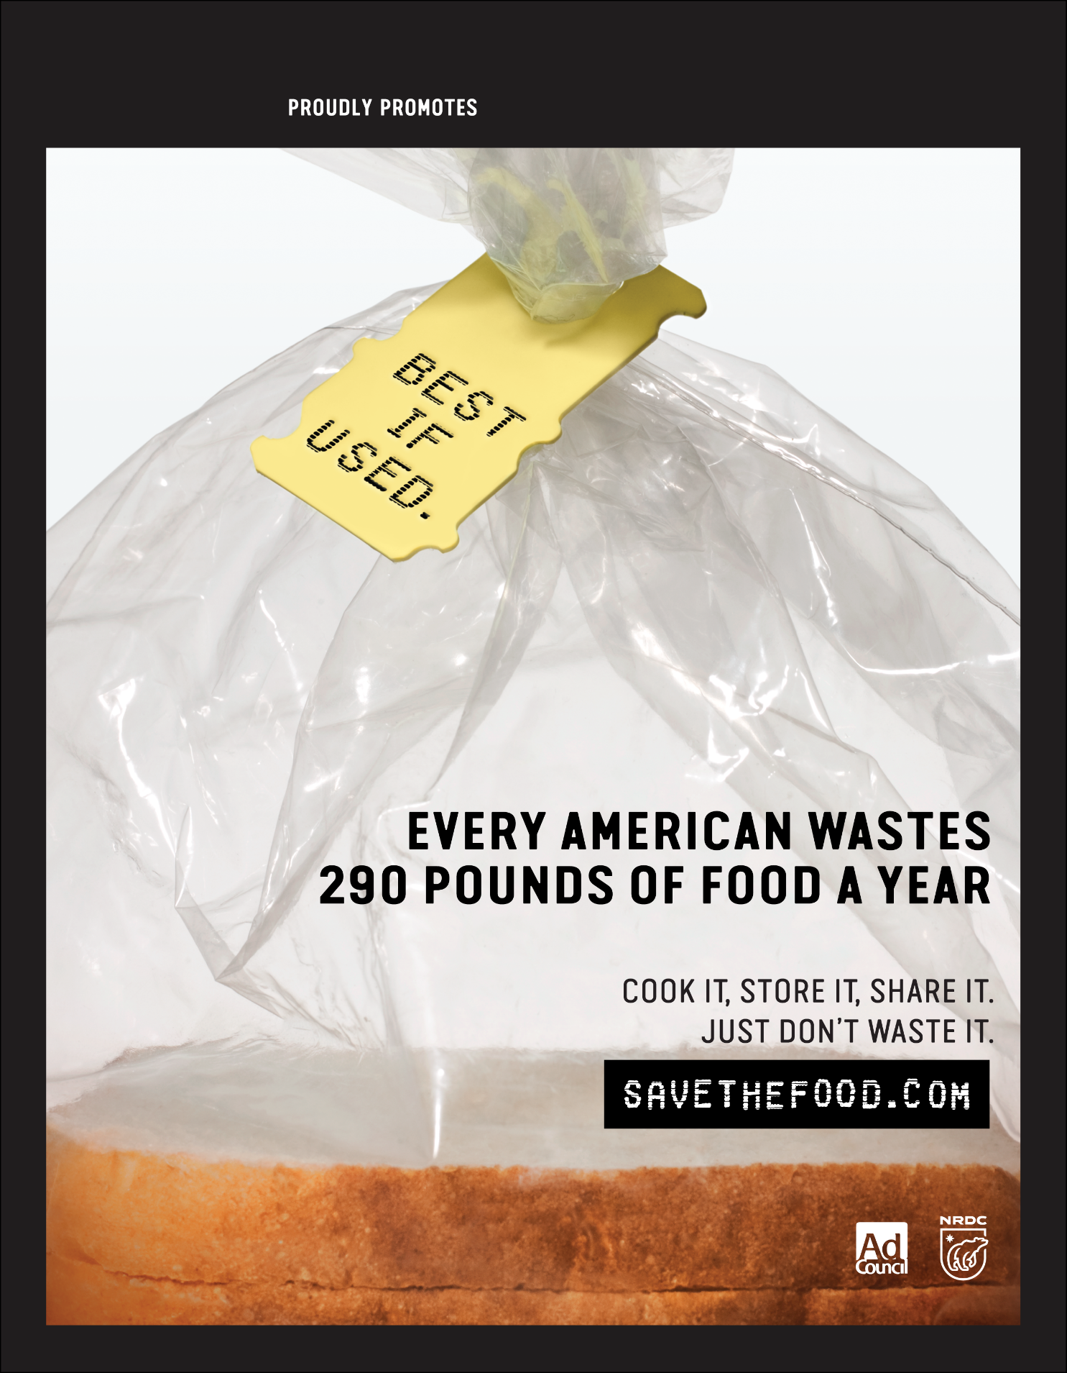
Figure 8: Approved for Co-Brand Upper Left Corner – Bread

DRAFT Messaging for Monday March 5, 2018
Food Waste Prevention Week partners are asked to utilize their social media platforms each day this week to issue shared messaging. Below are suggested social media posts and, where possible, Save the Food CA campaign materials and other videos for your convenience. For this suite of messages, we prefer consistent use of the following hashtags: #SaveTheFoodCA, #GoFurtherWithFood, #FeedPeopleNotLandfills on all posts and #SaveTheFood especially whenever directing online traffic to the official SaveTheFood campaign site or tools.
Monday – March 5, 2018
Official Organizational Launch
Suggested Social Media Posts
Today @Cal_OPR @CDFAnews and @ucanr recognized Food Waste Prevention Week in CA! Together we can #SaveTheFoodCA and make choices that #FeedPeopleNotLandfills. Join us and #GoFurtherWithFood starting this week.
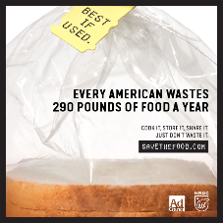
The US is losing up to 40% of its food from farm, to fork, to landfill. Yet, nearly 5 million Californians do not have consistent access to enough food. In CA, 1 in 8 are experiencing hunger and 1 in 5 of those are children. #GoFurtherWithFood this #NationalNutritionMonth #SaveTheFoodCA #FeedPeopleNotLandfills
Food Waste Reduction Heroes: PAUSE, LOOK, LEARN - Does your grocer offer discounted imperfect produce? If not, ask the manager if they will sell their slightly bruised or dinged produce at a discounted rate. #SaveTheFoodCA
Suggested Video Links
- Tasty "How to Make Veggie Stock From Kitchen Scraps" [1:56]
Learn how to create your own veggie stock from onion peels, potato skins, carrot tops and other kitchen scraps! Freeze them up to 3 months! #GoFurtherWithFood #SaveTheFoodCA
https://youtu.be/NcUEZaOp-5s
- Save The Food [0:44]
Check out this culinary creation! Better on a plate than headed for waste! #SaveTheFoodCA #FeedPeopleNotLandfills #GoFurtherWithFood #SaveTheFood
https://youtu.be/gk7io-3JccY
- Your Organization’s Leadership Video Message, if available. (Page 7 in the guide)

DRAFT Local Jurisdiction Proclamation
WHEREAS the month of March is National Nutrition Month; and
WHEREAS the theme for 2018’s National Nutrition Month is “Going Further with Food”; and
WHEREAS the U.S. is losing up to 40% of its food from farm, to fork, to landfill; and
WHEREAS nearly 5 million Californians are food insecure, lacking consistent access to enough food for an active, healthy life; and
WHEREAS food is not nutritious unless it is eaten; and
WHEREAS Californians throw away nearly 12 billion pounds of food; and
WHEREAS that unused food ultimately represents about 18 percent of all the material in landfills, turning into methane and contributing to climate change; and
WHEREAS the average family of four spends $1,500 on uneaten food every year; and
WHEREAS we all lose out on shared resources, like water and energy, used to produce and transport food that ultimately goes uneaten;
NOW, THEREFORE DO I/WE, [name of elected/body of electeds], HEREBY PROCLAIM the week of March 5th – 9th FOOD WASTE PREVENTION WEEK in [jurisdiction], and I/we encourage all residents to consider all options to prevent food from becoming waste in their homes, workplaces and communities.

Tuesday, March 6, 2018 – Find Food Waste
Activities: | - Encourage photos documenting where food waste is happening at their homes, worksites and communities.  - Issue social media messages related to why food waste matters, public messaging on the impacts of food waste  - The U.S. is losing up to 40% of its food from farm, to fork, to landfill.  - Nearly 5 million people are food insecure in CA.  - Excess food in landfills produces methane, a greenhouse gas 80x more potent than CO2.  If today is your jurisdiction’s regular public meeting, and elected officials will be issuing a local declaration, be sure to promote that activity on social media and to your workforce.
Tasks to Complete in Advance: | - Obtain final organizational approval for social media messages to be posted throughout the week and task a designated staff member to post the messages and associated videos/ resources on public-facing platforms, as appropriate.
Support Materials That Follow: | Draft Social Media Messages for Day 2

DRAFT Messaging for Tuesday, March 6, 2018
Tuesday – March 6, 2018
Find Food Waste
Suggested Social Media Posts
#SaveTheFoodCA – Preventing food from becoming trash protects the environment! Food is the single largest contributor to US landfills, rotting and releasing methane which contributes to climate change. #FeedPeopleNotLandfills #GoFurtherWithFood and promote sustainability. #SaveTheFood
An average family of 4 spends $1,500 on uneaten food each year. Learn simple ways to save $ - store food properly, eat or share your leftovers to #SaveTheFoodCA at home. Food Waste Reduction Heroes #GoFurtherWithFood and #FeedPeopleNotLandfills!
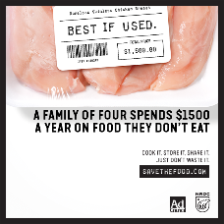
Food Waste Reduction Heroes: #SaveTheFood by learning to decode date labels and stop throwing away wholesome food too soon @SaveTheFood. #SaveTheFoodCA https://www.savethefood.com/tips/deciphering-dates-on-products
Food Waste Reduction Heroes: 84% of Americans report throwing away food that is close to, or past the date on the package, test your knowledge here. #SaveTheFoodCA
http://www.refed.com/tools/food-waste-policy-finder/spotlight-on-date-labeling/quiz

Suggested Video Links
- Save the Food “Extraordinary Life and Times of Strawberry” [1:59]
America is losing up to 40% of its food from farm, to fork, to landfill. Follow this extraordinary journey of a strawberry from the farm to your kitchen, and track what happens! #SaveTheFoodCA #SaveTheFood #FeedPeopleNotLandfills
https://www.youtube.com/watch?v=WREXBUZBrS8
- Natural Resources Defense Council “Food Matters: Food Waste” [3:08]
Check out this @SaveTheFood video to learn how food waste is generated and its implications. #GoFurtherWithFood #SaveTheFoodCA #SaveTheFood
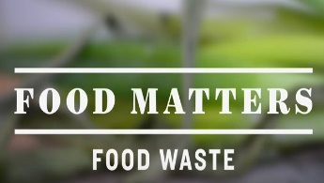
https://youtu.be/T6ObOTkpOQo
- PBS News Hour and NPR “Why does almost half of America’s food go to waste?” [9:05]
Salinas Valley, California produces 70% of our vegetables. Take a look at their local landfills. #FeedPeopleNotLandfills #SaveTheFoodCA
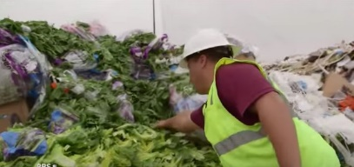
https://youtu.be/k8TDfjbpSBE
- NETNebraska “Tossed Out: Food Waste in America” [28:45]
Want more information about how food waste impacts climate change in landfills? This long-form video also includes informative breakdowns of various consumer food waste is filling up the dumps. #FeedPeopleNotLandfills #SaveTheFoodCA
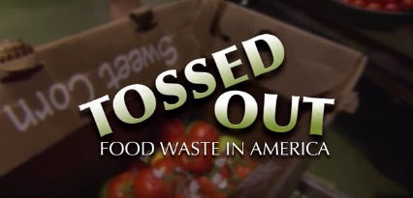
https://youtu.be/mLRjb6LdUFM

Wednesday, March 7, 2018 – Prevention by People
Activities: | - Encourage photos documenting how people will prevent food waste in their homes  - Issue social media messages related to individual-level solutions  If today is your jurisdiction’s regular public meeting, and elected officials will be issuing a local declaration, be sure to promote that activity on social media and to your workforce.
Tasks to Complete in Advance: | - Obtain final organizational approval for social media messages to be posted throughout the week and task a designated staff member to post the messages and associated videos/ resources on public-facing platforms, as appropriate.
Support Materials That Follow: | Draft Social Media Messages for Day 3

DRAFT Messaging for Wednesday March 7, 2018

Wednesday – March 7, 2018
Prevention by People
Suggested Social Media Posts
To reduce food waste, #SaveTheFood has 10 tips to reduce waste thru meal planning. These tips make it easier to save money, #FeedPeopleNotLandfills and #GoFurtherWithFood. #SaveTheFoodCA! www.savethefood.com/tips/10-easy-tips-for-meal-planning
#SaveTheFoodCA learn what those dates on food packages actually mean. #GoFurtherWithFood by knowing the difference between “use or freeze by,” “best by,” “sell by,” etc @SaveTheFood #FeedPeopleNotLandfills https://www.savethefood.com/tips/deciphering-dates-on-products
Food Waste Reduction Heroes: Challenge yourself to use the whole food in your recipes throughout the week. For example: Love carrots? Slice the carrots for a healthy snack and save the carrot greens for a soup broth later in the week. #SaveTheFoodCA

Suggested Video Links
- Save The Food “The Junk Food Truck” [1:14]
24 pounds of food is tossed by an average Californian each month. Watch a chef on a food truck turns nearly thrown out food into a gourmet meal! #SaveTheFood #FeedPeopleNotLandfills #SaveTheFoodCA
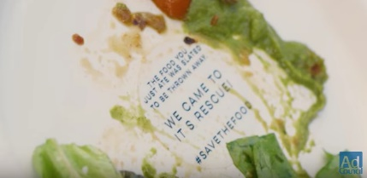
https://youtu.be/82UWJHQiq3E
- Save the Food “Save the Food Alexa Skill” [0:45]
#SaveTheFood and Alexa from Amazon can resolve proper food storage and freshness questions instantaneously! #GoFurtherWithFood #SaveTheFoodCA
https://youtu.be/2k4FJySKUQg

Thursday, March 8, 2018 – Prevention in Communities & Worksites
Activities: | - Encourage photos documenting how people will prevent food waste in their communities  - Issue social media messages related to community-level solutions  - Issue social media messages related to impacts on climate and natural resources  If today your jurisdictions’ regular public meeting, and elected officials will be issuing a local declaration, be sure to promote that activity on social media and to your workforce.
Tasks to Complete in Advance: | - Obtain final organizational approval for social media messages to be posted throughout the week and task a designated staff member to post the messages and associated videos/ resources on public-facing platforms, as appropriate.
Support Materials That Follow: | Draft Social Media Messages for Day 4

DRAFT Messaging for Thursday March 8, 2018
Thursday – March 8, 2018
Prevention in Communities & Worksites
Suggested Social Media Posts
Wasted food fills US landfills. Decaying food in landfills produces methane, a powerful greenhouse gas linked to climate change. Using tools like @SaveTheFood Guestimator can help Food Waste Reduction Heroes #FeedPeopleNotLandfills #SaveTheFoodCA #SaveTheFood
https://www.savethefood.com/guestimator/guests
#FeedPeopleNotLandfills. Reducing the amount of unused food headed for the trash helps families and businesses save money and protects the planet. #SaveTheFood by using food scraps, leftovers, and safe food even when it’s past its prime to #GoFurtherWithFood. #SaveTheFoodCA https://www.savethefood.com/cook-it
Wow! Producing a single burger uses as much H2O as taking a 90-min shower. Producing 1 lb of white rice? As much H20 as a 60-min shower. For 1 lb of bananas, a shower would run for 42 minutes. Tossed food wastes $ and natural resources. Cook, share, or store it. #SaveTheFoodCA
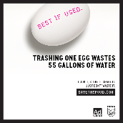
Food Waste Reduction Heroes: PAUSE, LOOK, LEARN - When you eat at a restaurant, do you eat your full portion? If not, ask for a half-order portion next time or take the leftovers to-go for lunch the next day. #SaveTheFoodCA

Suggested Video Links
- ReFED “Roadmap to Reduce U.S. Food Waste by 20% (Animated Explainer Video)” [2:57]
Learn how we can reduce US food waste by 20% and save $100 billion dollars through prevention, recovery, and recycling! #GoFurtherWithFood #SaveTheFood #SaveTheFoodCA
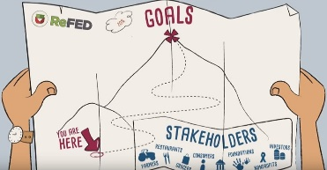
https://youtu.be/OHfKC9BFn5k
- Environmental Protection Agency “Feed People, Not Landfills” [2:54]
Wasted food is the largest component sent to landfills in the US. The food waste in landfills decay into methane, a powerful greenhouse gas linked to climate change. Watch EPA’s video on how we can #FeedPeopleNotLandfills. Join us to #SaveTheFoodCA
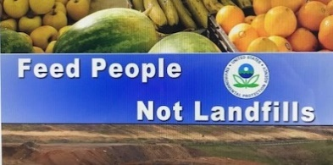
https://youtu.be/EwNpnUUSk4M
- Institute for Local Self-Reliance “What is Community Composting? Video Featuring Composters From Around the US” [7:40]
What can you do with inedible food in your community? Listen to current US community composters about feeding your soils and diverting food from landfills! #FeedPeopleNotLandfills #SaveTheFoodCA
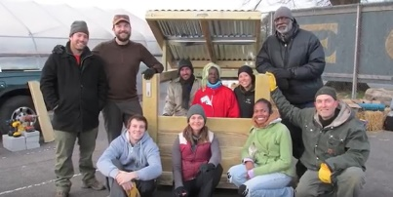
https://youtu.be/Eg9ba019npg

Friday, March 9, 2018 – Keep it Going!
Activities: | - Issue social media messages to spark ongoing actions to reduce food waste in CA  If today is your jurisdiction’s regular public meeting, and they will be issuing a local declaration, be sure to promote that activity on social media and to your workforce.
Tasks to Complete in Advance: | - Obtain final organizational approval for social media messages to be posted throughout the week and task a designated staff member to post the messages and associated videos/ resources on public-facing platforms, as appropriate.
Support Materials That Follow: | Draft Social Media Messages for Day 5

DRAFT Messaging for Friday, March 9, 2018
Friday – March 9, 2018
Keep it Going!
Suggested Social Media Posts
Lots of food is wasted at home. #SaveTheFoodCA by determining what causes your food waste. Advocate for changes that will help you waste less. #GoFurtherWithFood #FeedPeopleNotLandfills #SaveTheFood
www.savethefood.com/tips/shopping-guidelines
Don’t cry over curdled milk or lament limp lettuce. There are many ways to use less than perfect food. To #SaveTheFood, revive items from the brink. Help #FeedPeopleNotLandfills and #GoFurtherWithFood. For more ideas, check out Dana Gunders Waste Free Kitchen Handbook.
https://www.savethefood.com/cook-it.
Food Waste Reduction Heroes: Saving money from reducing food waste? If you can, donate your savings to your local foodbank. Continue to stay involved in Food Waste Prevention, and join the #SaveTheFood listserv: https://act.nrdc.org/signup/food-waste-ad-council/

Suggested Video Links
- Hatch Kids/SheKnows “Kids Go Undercover to Discover Food Waste in their Homes” [3:30] Watch these young Food Waste Reduction Heroes pinpoint food waste in their homes and share their lessons on what they learned! #SaveTheFoodCA
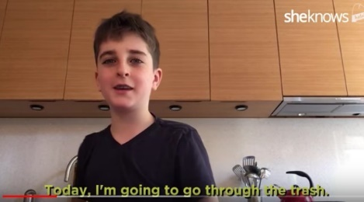
https://www.youtube.com/watch?time_continue=2&v=mn_dsgG0vKs
- TED “A Guerilla Gardener in South Central LA - Ron Finley” [10:45]
Take action as a Food Waste Reduction Hero! Find out how urban gardening can build communities and increase our connection with food and health! #SaveTheFoodCA #GoFurtherWithFood
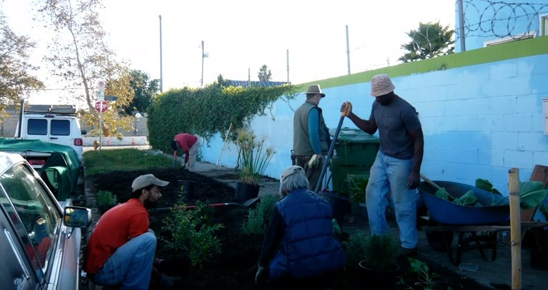
https://youtu.be/EzZzZ_qpZ4w
- TED^{x} “A recipe for cutting food waste - Peter Lehner” [14:37]
Food waste is costly, and consumers and businesses are taking steps to recover those food. Watch this TED talk about some effective solutions and what we, Food Waste Reduction Heroes, can do! #SaveTheFoodCA #FeedPeopleNotLandfills #SaveTheFood
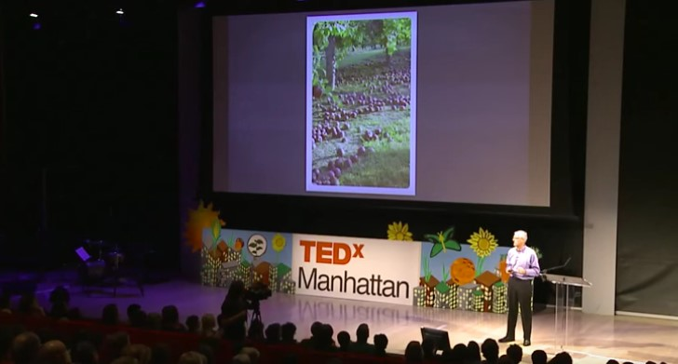
https://youtu.be/UwOHpWTRsbE

To keep the messages going beyond Food Waste Prevention Week:
Want more food system videos? Check out Food Tanks’ 24 TED Talks That Will Help Save the Food System.
Check out this ugly fruit and vegetable campaign: http://www.endfoodwaste.org/ugly-fruit---veg.html
Find local organizations that rescue food and where they donate: http://sustainableamerica.org/foodrescue/
Learn more about food banks to donate extra food: http://ampleharvest.org or http://www.feedingamerica.org/find-your-local-foodbank/

Advance Prep Overview and Suggested Timeline
Suggested completion by February 1:
  - Meet with your Agency Director or Department Head to establish buy-in and support for Food Waste Prevention Week activities.
  - Schedule time with your Agency Director or Department Head to tape a video message for the workforce.
  - Designate and orient staff best positioned to lead, or assist with, coordination of Food Waste Prevention Week activities.
  - Secure space on public meeting agendas, as appropriate, to have elected officials formally proclaim or declare Food Waste Prevention Week in their jurisdiction during the week of March 5th.

Suggested completion by February 9:
- Obtain final organizational approval for co-branding any print materials with your logo. Arrange to print, disseminate and display co-branded poster for lobbies/public waiting spaces.
Suggested completion by February 23:
- Finalize a Leadership Endorsement on Food Waste Prevention Week.
- Finalize the video script with organizational context, shoot the video message and make any final preparations for dissemination to the workforce.
- Designate a staff member to coordinate distribution of co-branded posters.

Suggested completion by March 1:
  - Obtain final organizational approval for social media messages to be posted throughout the week and designate a staff member to post the messages and associated videos/ resources on public-facing platforms, as appropriate.
  - Task a designated staff member to post approved co-branded images or web banners to internal and/or external websites, as appropriate.
  - If your organization will issue a press release or engage local media outlets, finalize the press release to be issued on 3/5/18. Don’t forget: identify a spokesperson to be ready to respond to any media inquiries.

Appendix:
Anticipated State Agency Announcements for Food Waste Prevention Week
- Letter of Support from Governor Brown
- Food Waste Prevention Week Announcement by Governor’s Office of Planning & Research
- Food Waste Prevention Week Announcement by California Department of Food & Agriculture
- Food Waste Prevention Week Announcement by CalRecycle
- Food Waste Prevention Week Announcement by University of California, Division of Agriculture and Natural Resources, and its Nutrition Policy Institute
- PLACEHOLDER for additional State agencies TBD
State Agency Announcements may include narrative such as:
The _______ is pleased to announce March 5th through 9th, 2018, as “Food Waste Prevention Week” in the State of California.
CalRecycle estimates that Californians throw away almost 12 billion pounds of food each year. That food waste amounts to 18% of all landfill use in this state. In contrast, nearly 5 million Californians are food insecure, lacking consistent access to sufficient, safe and nutritious food to lead a healthy, active life. Nutritious food from California farms and ranches should feed people rather than landfills.
The financial and environmental costs associated with agricultural inputs are lost when food goes unused—these include energy, water, fertilizer, land, production, storage and transportation, not to mention retail and consumer costs. A family of four pays, on average, about $1500 toward 1000 pounds of uneaten food every year.
Food waste prevention also aligns with California’s 75 Percent Initiative to significantly reduce solid waste in landfills by 2020. Unused food in landfills decomposes very slowly, releasing methane, a greenhouse gas 80 times stronger than CO₂ at trapping heat, and contributes to climate change. To protect shared resources and reduce greenhouse gas emissions, it is imperative that everyone joins in to divert usable food from landfills.
This week, in alignment with National Nutrition Month’s theme “Going Further with Food,” ______ encourages people to take simple food waste prevention actions such as sharing or freezing food before it becomes inedible and using leftovers. This week, ____ encourages people enact food waste solutions and consider factors in their homes, worksites, or communities that make preventing food waste difficult due to current purchasing, storage, or disposal options.
Taking steps to be aware of food waste and to initiate changes to prevent it has the power to reduce waste, to feed people rather than landfills, to combat climate change and to save economically. Working together, we can Save The Food in California.

DRAFT Collective Press Release
For Immediate Release:  March 5, 2018 | For more information contact:  <Office>  <Phone>  <Email>

DURING FOOD WASTE PREVENTION WEEK MULTIPLE AGENCIES CHALLENGE CALIFORNIANS TO BECOME FOOD WASTE REDUCTION HEROES
<CALIFORNIA> –Governor Jerry Brown has issued a letter of support and the Governor’s Office of Planning and Research, California Department of Food & Agriculture, CalRecycle, University of California, Division of Agriculture and Natural Resources, and many others have announced March 5-9, 2018, as “Food Waste Prevention Week” in the State of California. Agencies across the state have established a collaborative partnership committed to raising public awareness about the impacts of wasted food on nutrition, climate, population and economy.
“Each year, Californians throw away nearly 12 billion pounds of food, representing about 18 percent of all the material in landfills,” said [SENIOR OFFICIAL TBD]. “Unused food uses California’s critical water and energy resources, produces greenhouse gases in landfills, and neglects to support our state’s food insecure individuals and families.”
Consumers generate more food waste than grocery stores and restaurants combined. Forty percent of all food waste happens at the individual or household level, and ninety percent of Americans throw away food that could be eaten in part due to confusing expiration date labels and uncertainty about food storage and freshness. The Natural Resources Defense Council estimates that an average family of four throws away about 1,000 pounds of food each year, at a cost of roughly $1,500.
All sectors have a role in reducing food waste. Large government agencies, businesses, schools, faith- and community-based organizations are encouraged to determine how they can limit food waste and act on those solutions. Food Waste Prevention Week aims to bring awareness to everyone in California about solutions they can bring about in their homes, workplaces and community.
Reducing food waste has the potential to shift available resources to the nearly 5 million Californians who are food insecure. Experts at ReFED, a multi-stakeholder nonprofit committed to reducing US food waste, have determined that each pound of food diverted from waste can create 1.2 meals.
Food waste is also the single largest item in landfills. Once there, food decomposes and releases methane - a climate pollutant 80 times more potent than carbon dioxide (CO₂).
During Food Waste Prevention Week, collaborating agencies are raising awareness of the importance of better utilizing food resources and committing to educating their staff and ensuring their organizations reduce their food waste.
Agencies actively participating include: Governor’s Office of Planning and Research, State of California; Berkeley Media Studies Group; CalRecycle; California Department of Education; California Department of Food & Agriculture; California Department of Public Health; California Dietetic Association; Dairy Council of California; Natural Resources Defense Council; Nutrition Policy Institute; Public Health Alliance of Southern California; Public Health Institute; University of California, Division of Agriculture and Natural Resources (UCANR); UC CalFresh Nutrition Education Program; and UCANR - Nutrition, Family, and Consumer Sciences Program and Expanded Food and Nutrition Education Program.
For more information on how to store, save and use food, please visit SaveTheFood.com.
###

Why a Food Waste Reduction Hero Photo Challenge?
The Food Waste Reduction Hero Photo Challenge encourages the California community to visually document food waste reduction barriers or efforts in their daily lives. This creative process of capturing visual records instills self-empowerment in the participant’s ability to act on change based on understanding barriers to food waste prevention. The resulting photos or videos becomes an opportunity to express their experiences through social change and quantifies the impact of Food Waste Prevention Week outreach.

A full checklist of advanced preparation tasks with suggested timeline is included later in the Guide.
California Department of Resources, Recycling and Recovery (CalRecycle)
Natural Resources Defense Council https://www.nrdc.org/issues/food-waste
Images proposed for inclusion on daily social media posts are available at https://www.savethefood.com/share-it

